WEB DEVELOPMET

SUBJECT CODE-WEDE5020

NAME- RENDZO

SURNAME-RIKHOTSO

ST10510131

GROUP 3
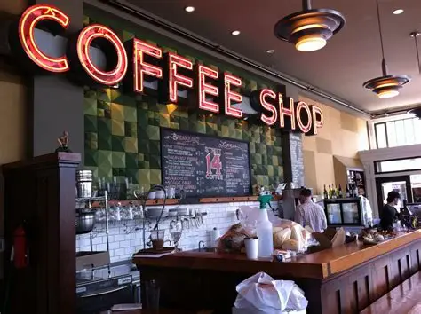

TABLE OF CONTENT
1. Proposal 1: Brew Haven Coffee Shop ........................................ 1
1.1 Organisation Overview ......................................................... 1
1.2 Website Goals and Objectives ............................................. 1
1.3 Website Features and Functionality .................................... 2
1.4 Design and User Experience ................................................ 2
1.5 Technical Requirements ....................................................... 2
1.6 Timeline and Milestones ....................................................... 3
1.7 Budget ...................................................................................... 3
1.8 References ................................................................................ 3
2. Proposal 2: Fresh Fade Barbershop ........................................ 4
2.1 Organisation Overview ......................................................... 4
2.2 Website Goals and Objectives ............................................. 4
2.3 Website Features and Functionality .................................... 5
2.4 Design and User Experience ................................................ 5
2.5 Technical Requirements ....................................................... 5
2.6 Timeline and Milestones ....................................................... 6
2.7 Budget ...................................................................................... 6
2.8 References ................................................................................ 6
3. Conclusion ...................................................................................

Proposal 1 — Coffee Shop
Organization Name: Brew Haven Coffee Shop

1. Organization overview
Brew Haven is a fictional local coffee shop that provides freshly brewed coffee, tea, pastries and light meals to students, professionals and members of the local community. The business aims to create a comfortable environment where customers can enjoy quality beverages and food. Its mission is to provide affordable, high-quality coffee and excellent customer service. Its vision is to become a popular and trusted coffee destination within the local community. The primary target audience includes students, young professionals, coffee enthusiasts and people looking for a comfortable place to meet or work.

2. Website Goals and Objectives
The main goal of the website is to establish an online presence for Brew Haven and make information about the business easily accessible. The website should increase customer awareness, display the menu and encourage customers to visit the coffee shop. Key performance indicators will include website visits, menu views, contact enquiries and customer engagement.

3. Website Features and Functionality
The website will include a homepage introducing the coffee shop, an About Us page, a menu page displaying available products and prices, and a Contact page containing the location, operating hours and contact details. The website may also include an image gallery and a special-offers section.

4. Design and User Experience
The proposed colour palette will use warm brown, cream and beige colour to create a welcoming coffee-shop atmosphere. Typography will be simple and easy to read. The website will have a clean layout with a navigation bar that allows users to move easily between pages. A low-fidelity wire frame will be created to demonstrate the positioning of the navigation bar, images, text, menu and contact information.

5. Technical Requirements
The website will be developed using HTML, CSS and JavaScript. It will be designed to work on desktop computers, tablets and smartphones. A domain name and web-hosting service will be required when the website is deployed.

6. Timeline and Milestones
The project will involve planning and research, wireframe development, website design, coding, testing and final deployment.

7. Budget
The estimated budget will include costs for domain registration, hosting and future website maintenance. Development costs will be kept low because the website is being developed as an academic project.

References
- W3C (2023). Web Content Accessibility Guidelines (WCAG) 2.2. Available at: W3C WCAG 2.2 (Accessed: 11 August 2026).
- Google (2024). Mobile-friendly websites. Available at: Google Search Central (Accessed: 11 August 2026).
- Square (2024). Coffee shop marketing and business resources. Available at: Square Coffee Shop Resources (Accessed: 11 August 2026).
- Shoplift (2024). How to start a coffee shop. Available at: Shoplift Coffee Shop Guide (Accessed: 11 August 2026).

